**CHAPTER 1**

# **INTRODUCTION**

**Web Technology**

* **Web programming**, also known as **web development**, is the creation of dynamic web applications. There are two broad divisions of web development – front-end development (also called client-side development) and back-end development (also called server-side development).
* Front-end development refers to constructing what a user sees when they load a web application – the content, design and how you interact with it. This is done with three codes – HTML, CSS and JavaScript. HTML, short for Hyper Text Markup Language, is a special code for ‘marking up’ text in order to turn it into a web page. Every web page on the net is written in HTML, and it will form the backbone of any web application. CSS, short for Cascading Style Sheets, is a code for setting style rules for the appearance of web pages. CSS handles the cosmetic side of the web. Finally, JavaScript is a scripting language that’s widely used to add functionality and interactivity to web pages.
* Back-end development controls what goes on behind the scenes of a web application. A back-end often uses a database to generate the front-end.

**Web applications**

* In computing, a **web application** or **web app** is a client-server program which the client (including the user interface and client-side logic) runs in a web server.
* Common web applications include webmail, online retail sales, and online auction.

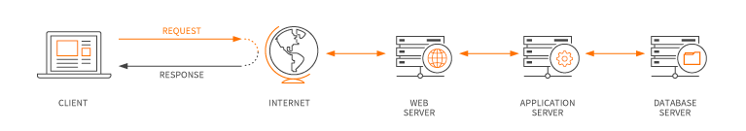Fig 1.1: Web Application Diagram

* Web applications use a combination of server-side scripts (PHP and ASP) to handle the storage and retrieval of the information, and client-side scripts (JavaScript and HTML) to present information to users.
* This allows users to interact with the company using online forms, content management systems, shopping carts and more. In addition, the applications allow employees to create documents, share information, collaborate on projects, and work on common documents regardless of location or device.
  1. **Problem Statement**

The purpose of this project is to quantify the service satisfaction levels of customers who make of food catering services for their functions like wedding, get together, family function, public/corporate meetings, etc.

* 1. **Objective**

The main objective of this mini project is to increase the customer satisfaction and to determine the relationship with customer satisfaction by developing an application using web technologies.

**1.3 Scope**

This project enables people to order food online and get it delivered to their homes. It can be done by calling the caterer or by just placing the order on the catering website.

**CHAPTER 2**

# **REQUIREMENT ANALYSIS**

The purpose of this paper is to examine the different methods in gathering requirements. Requirements are one of the most vital pieces to ensuring the success of a system or project. To ensure the optimal requirements are received, the methods in which those requirements are obtained are equally important.

Requirements are one of the most vital pieces to ensuring the success of a system or project. To ensure the optimal requirements are received, the methods in which those requirements are obtained are equally important

**Types of requirements analysis**:

1. **One-on-one interviews**:

One-on-one interviews are the most common technique for gathering requirements, as well as one of the primary sources of requirements. To help get the most out of an interview, they should be well thought out and prepared before sitting with the interviewee. The analyst should identify stakeholders to be interviewed. These can be users who interact with the current or new system, management, project financers or anyone else that would be involved in the system.

## **Group Interviews:**

Group interviews are similar to one-on-one interview, except there is more than one person being interviewed. Group interviews work well when the interviewees are at the same level or position. A group interview also has an advantage when there is a time constraint.

## **Questionnaires/Surveys:**

Questionnaires, or surveys, allow an analyst to collect information from many people in relatively short amount of time. This is especially helpful when stakeholders are spread out geographically, or there are dozen to hundreds of respondents whose input will be needed to help establish system requirements.

## **User Observation:**

The direct approaches of interviewing and questionnaires provide valuable user feedback based on the questions asked of them; however, there are times when direct observation may be better suited in requirement gathering. To get a better understanding of a user in their in current work environment, the analyst may observe the user themselves. User observation is helpful in assisting the analyst by getting a full grasp of how the user interacts with the system, first hand.

**CHAPTER 3**

# **SYSTEM REQUIREMENT SPECIFICATION**

* Requirements analysis is critical for project development. Requirements must be documented, actionable, measurable, testable and defined to a level of detail sufficient for system design.
* Requirements can be  [architectural](http://en.wikipedia.org/wiki/System_architecture),  [structural](http://en.wikipedia.org/wiki/Structure),  [behavioural](http://en.wikipedia.org/wiki/Behavior),  [functional](http://en.wikipedia.org/wiki/Functional_requirements), and  [non-functional](http://en.wikipedia.org/wiki/Non-functional_requirements). A software requirements specification (SRS) is a comprehensive description of the intended purpose and the environment for software under development.
  1. **Hardware Requirement**
* Minimum of 2 GB of main memory
* Minimum of 3 GB of storage
* Keyboard
* Mouse
* Display Unit
* Dual-Core or AMD with minimum of 1.5 GHz speed

**3.2 Software Requirement**

* Windows – XP/7/8/10
* Notepad++/Sublime Text
* Xampp Control Panel
* Browser - Chrome, Firefox

**CHAPTER 4**

# **ANALYSIS AND DESIGN**

The core part of website development and design is not necessary the coding process. Indeed, such technologies as HTML, CSS, and JavaScript give the web we know its shape and define the way we interact with the information. But what usually stay behind the scenes and, at the same time, remain the crucial part of website development life cycle are the stages of preliminary information gathering, detailed planning, and post-launch maintenance.

## We have followed some of the steps of Website Development Life Cycle to do our mini project.

## **Website Development Life Cycle**

## **Step 1. Gathering Information:**

## The most important task at this point is to get the clear understanding of your future website purposes, the main goals you wish to get, and the target audience you want to attract to your site. Such kind of a website development questionnaire helps to develop the best strategy for further project management.

## **Step 2. Planning:**

## At this stage of website development cycle, the developer creates the data that can give to a customer an opportunity to judge how the entire site will look like.

## On the basis of the information that was gathered together in the previous phase, the sitemap is created.

**Web Site**

**Contact**

**About**

**Menu**

**Home**

Fig 4.1: Sitemap of the Website

**Step 3. Design:**

### **Website layout** is the result of designer’s work. It can be a graphic sketch or an actual graphic design. The primary function of the layout is to represent the information structure, visualize the content, and demonstrate the basic functional. Layouts contain colours, logos, images and can give a general understanding of the future product.

### **Step 4.  Content Writing and Assembly:**

### Content writing and compiling usually overlaps with other stages of website creation, and its role can’t be underestimated.  At this step it is necessary to put in writing the very essence you’d like to communicate to the audience of your website, and add calls-to-action. Content writing involves also creation of catching headlines, text editing, writing new text, compiling the existing text, etc., which takes time and effort. As a rule, the client undertakes to provide website content ready to migrate to the site. It is better when all website content is provided before or during website coding.

### **Step 5. Coding**:

### At this step, you can finally start creating the website itself. Graphic elements that have been designed during the previous stages should be used to create an actual website. Usually, the home page is created first, and then all sub-pages are added, according to the website hierarchy.

### **Step 6. Testing:**

### Testing is probably the most routine and important part of a process. Every single link should be tested to make sure that there are no broken, forms and scripts that are used must be tested before deploying the project, validation of user input must be done.

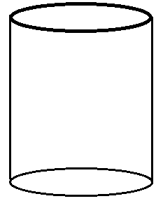 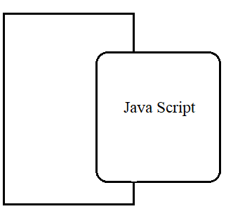

HTML

**SERVER PAGE**

Fig 4.2: Web System Architecture

**CHAPTER 5**

**IMPLEMENTATION**

**5.1 File Structure**

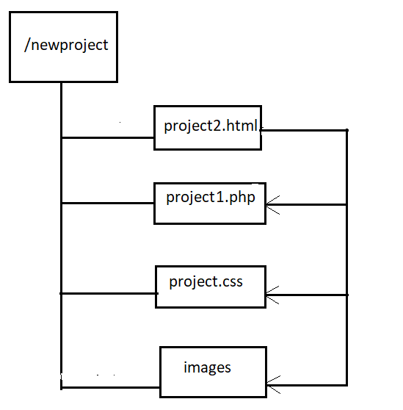 Fig 5.1: File Structure of the Project

The above figure depicts the file structure of the project that has been implemented. The root node or the directory in which all the essential files are stored is the newproject directory (or the main file). It contains four other important subfiles.

* File project2.html contains the html code. It contains several important tags like <div>, <body>, <html> etc,,.
* File project1.php contains the PHP code (server side code).
* File project.css is the CSS file.
* File image is the image file which contains all the images that are used.
  1. **Technologies Used**
     1. **HTML (Hyper Text Markup Language)**

Hypertext Markup Language (HTML) is the standard markup language for creating web pages and web applications.  HTML tags are the building blocks of HTML pages. With HTML constructs, [images](https://en.wikipedia.org/wiki/HTML_element#Images_and_objects) and other objects such as interactive forms may be embedded into the rendered page. HTML provides a means to create structured documents by denoting structural semantics for text such as headings, paragraphs, links, quotes and other items. Tags such as <img/> and <input/> directly introduce content into the page. Other tags such as <p> surround and provide information about document text and may include other tags as sub-elements. Browsers do not display the HTML tags, but use them to interpret the content of the page.

* + 1. **CSS (Cascading Style Sheets)**

Cascading Style Sheets (CSS) is a style sheet language used for describing the presentation of a document written in a markup language like HTML. CSS is designed to enable the separation of presentation and content, including layout, colours, and fonts.

* + 1. **JavaScript**

JavaScript often abbreviated as JS, is a [high-level](https://en.wikipedia.org/wiki/High-level_programming_language), [interpreted](https://en.wikipedia.org/wiki/Interpreted_language) [programming language](https://en.wikipedia.org/wiki/Programming_language). It is a language which is also characterized as [dynamic](https://en.wikipedia.org/wiki/Dynamic_programming_language), [weakly typed](https://en.wikipedia.org/wiki/Weak_typing), [prototype-based](https://en.wikipedia.org/wiki/Prototype-based_programming) and [multi-paradigm](https://en.wikipedia.org/wiki/Multi-paradigm_programming_language). As a multi-paradigm language, JavaScript supports [event-driven](https://en.wikipedia.org/wiki/Event-driven_programming), [functional](https://en.wikipedia.org/wiki/Functional_programming), and [imperative](https://en.wikipedia.org/wiki/Imperative_programming) (including [object-oriented](https://en.wikipedia.org/wiki/Object-oriented_programming) and [prototype-based](https://en.wikipedia.org/wiki/Prototype-based_programming)) [programming styles](https://en.wikipedia.org/wiki/Programming_paradigm). It has an [API](https://en.wikipedia.org/wiki/Application_programming_interface) for working with text, [arrays](https://en.wikipedia.org/wiki/Array_data_type), dates, [regular expressions](https://en.wikipedia.org/wiki/Regular_expression), and basic manipulation of the [DOM](https://en.wikipedia.org/wiki/Document_Object_Model), but the language itself does not include any [I/O](https://en.wikipedia.org/wiki/Input/output), such as networking, storage, or graphics facilities, relying for these upon the host environment in which it is embedded.

* + 1. **PHP**

Hypertext Preprocessor (or simply PHP) is a [server-side scripting](https://en.wikipedia.org/wiki/Server-side_scripting) language designed for [Web development](https://en.wikipedia.org/wiki/Web_development), and also used as a [general-purpose programming language](https://en.wikipedia.org/wiki/General-purpose_programming_language). PHP code may be embedded into [HTML](https://en.wikipedia.org/wiki/HTML) code, or it can be used in combination with various [web template systems](https://en.wikipedia.org/wiki/Web_template_system), web content management systems, and [web frameworks](https://en.wikipedia.org/wiki/Web_framework). PHP code is usually processed by a PHP [interpreter](https://en.wikipedia.org/wiki/Interpreter_(computing)) implemented as a [module](https://en.wikipedia.org/wiki/Plugin_(computing)) in the web server or as a [Common Gateway Interface](https://en.wikipedia.org/wiki/Common_Gateway_Interface) (CGI) executable.

**5.3 Functions Used at Client and Server sides**

**5.3.1 Functions at Client side:**

1. **Scrolling function**

function scrollFunction() {

if (document.body.scrollTop > 830 || document.documentElement.scrollTop > 860)

document.getElementById("myBtn").style.display = "block";

else

document.getElementById("myBtn").style.display = "none";

}

Scrolling function is used to scroll to the first page(or top). This reduces the time to scroll up to the top (or first page).

1. **To display the menu content:**

<button class="collapsible">Food Catering Specials</button>

<div class="content">

<h4>Bread Basket</h4>

<p class="w3-text-grey">Assortment of fresh baked fruit breads and muffins 5.50</p><br>

<h4>Honey Almond Granola with Fruits</h4>

<p class="w3-text-grey">Natural cereal of honey toasted oats, raisins, almonds and dates 7.00</p><br>

</div

The above code is used to display the content(s) of the menu. It helps the user to go through various food items.

**5.3.2 Functions at Server side:**

1. **Database connection**

$conn = new mysqli($dbhost, $dbuser,$dbpass, $db);

if($conn->connect_error)

die("connection failed".$conn->connect_error);

The above code is used to connect to the database.

1. **Inserting records into the database**

if(isset($_POST['sub']))

{

$sql="INSERT INTO catering (Name, People, Message) VALUES ('".$_POST['Name']."','".$_POST['People']."','".$_POST['Message']."')";

if($conn->query($sql)==TRUE) { echo "New record created successfully";

$message = "Thank you. Your Message Has Been Saved successfully ";

echo "<script type='text/javascript'>alert('$message');</script>";

include("project2.html");}else echo "New record is not created ":

}

The above code is used to insert a new record into the database. On success it prints "New record created successfully" (not necessary to display it on the browser) else it prints "New record created successfully".

**CHAPTER 6**

**TESTING**

**6.1 Testing Techniques**

Software testing techniques help you design better cases. Since exhaustive testing is not possible, testing techniques help reduce the number of test cases to be executed while increasing test coverage. They help identify test conditions that are otherwise difficult to recognize.

**6.2 Software Testing Fundamentals**

During earlier definition and development of software quality assurance and represents the ultimate review of specification, design and coding. The increasing visibility of software as a system element and attendant “costs” associated with a software failure is motivating force for well planned, through testing.

**6.3 Testing Objective**

A number of rules that can serve well as testing objectives:

* Testing is a process of executing a program with the intent of finding an error.
* A good test case is one that has high probabilities of finding an undiscovered error. A successful test is one that uncovers as undiscovered error.
* The objective is to design test systematically to uncover different classes of errors and do so with minimum amount of time and effort.

Testing cannot show the absence of defects, it can only show the software defects that are present.

**6.4 Test Cases**

|  |  |
| --- | --- |
| **SI # Test Case :-** | **1** |
| **Name of the Page** | **Contact** |
| **Expected Output** | **Name-ABC** |
| **Actual Output** | **Field Name Missing** |
| **Status** | **Fail** |
| **Remarks** | **User Has Not Filled the Information** |

Table 6.1: Test Case 1

|  |  |
| --- | --- |
| **SI # Test Case :-** | **2** |
| **Name of the Page** | **Contact** |
| **Expected Output** | **Message Has Been Saved Successful** |
| **Actual Output** | **New Record Not Been Created** |
| **Status** | **Fail** |
| **Remarks** | **User Has Given Wrong Data** |

Table 6.2: Test Case 2

|  |  |
| --- | --- |
| **SI # Test Case :-** | **3** |
| **Name of the Page** | **Contact** |
| **Expected Output** | **Name-ABC** |
| **Actual Output** | **Name-ABC** |
| **Status** | **Pass** |
| **Remarks** | **User Has Filled the Information** |

Table 6.3: Test Case 3

**CHAPTER 7**

**SNAPSHOTS**

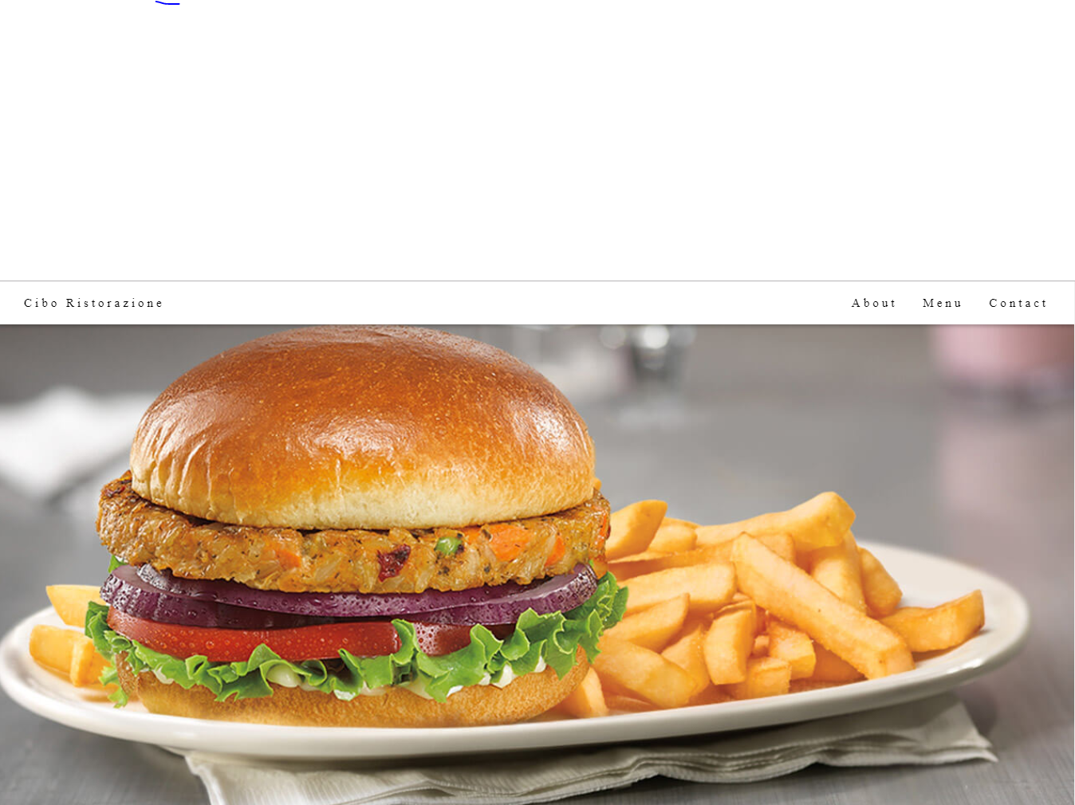

Fig 7.1: Home Section

This section is the first section of the web page which gives the insight of the website.

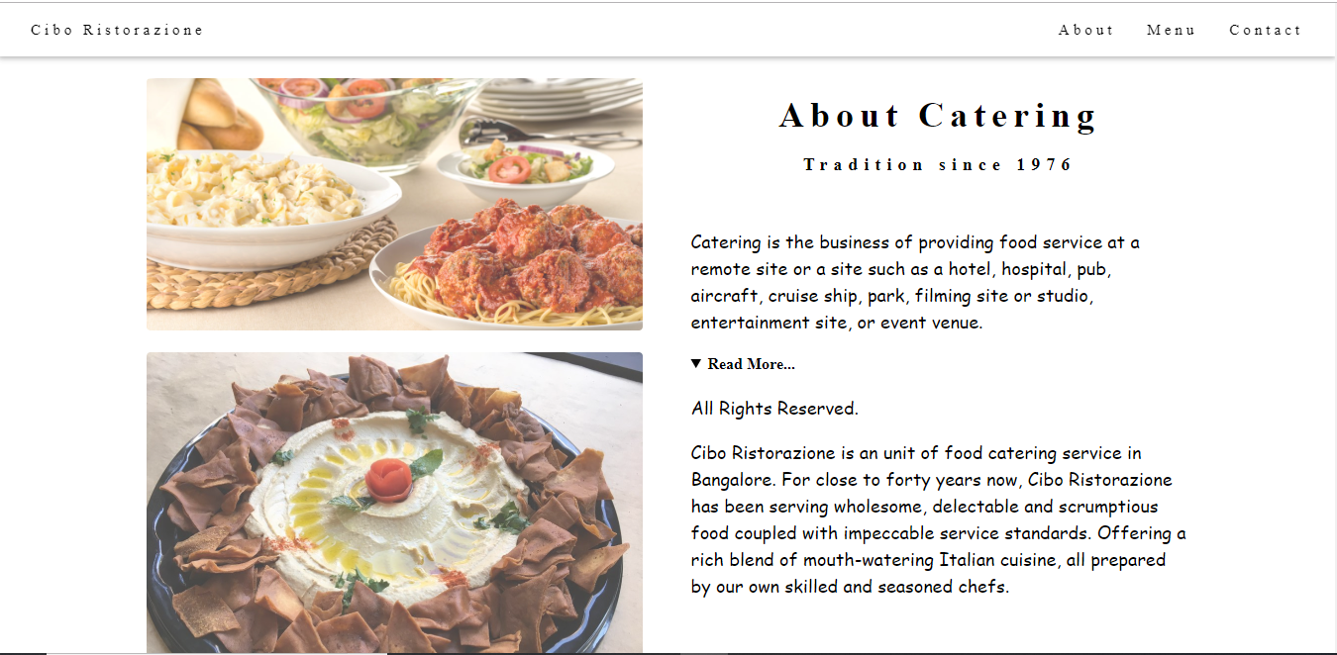 Fig 7.2: About Section

This section gives the information about the catering website.

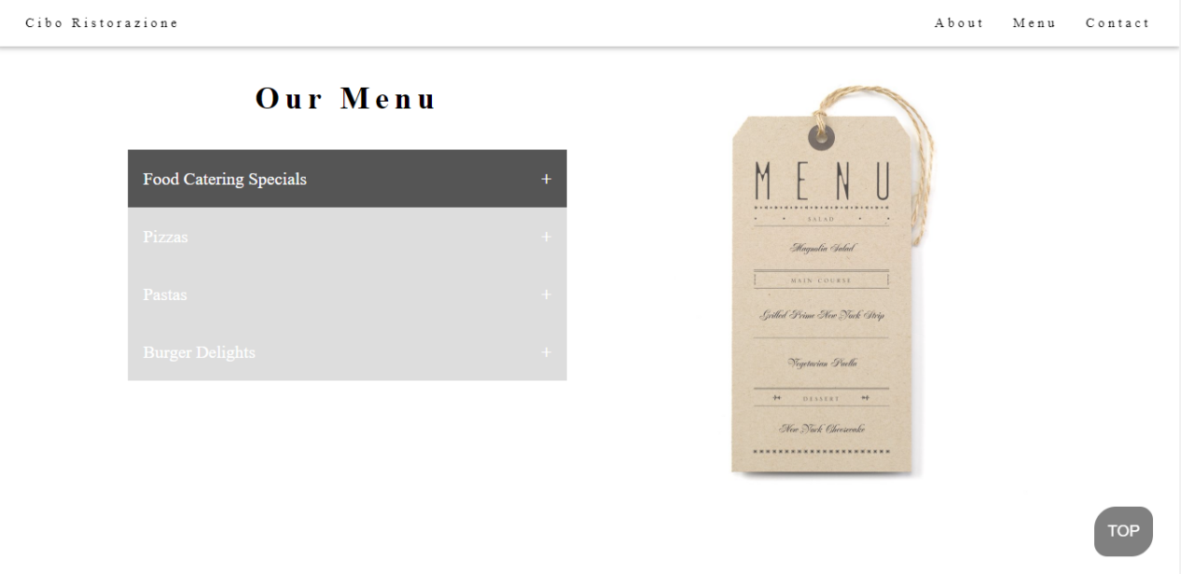

Fig 7.3: Menu Section

This section displays the menu of the food items available for people to order.

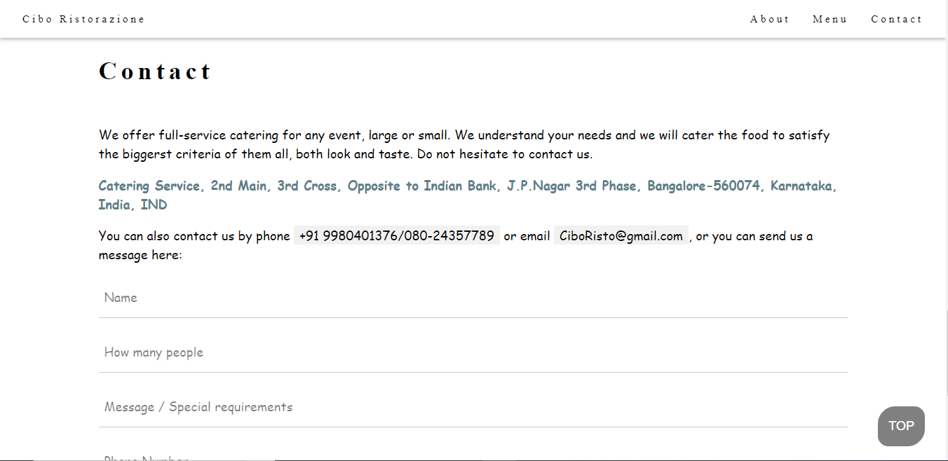

Fig 7.4: Contact Section

This section displays the contact information of the catering service. The user can also place an order in this section.

**CONCLUSION**

This project is to develop a website for a catering service with the help of web technologies like HTML, CSS, JavaScript and PHP.

Web technology plays a major role in today’s world where visualization and interaction takes the upper hand as compared to textual interaction. This is largely true as we can see user interface becoming more and more attractive, all thanks to major leaps in the field of web development. The project is implemented using Xampp, a free and open-source cross-platform web server solution stack package developed by Apache Friends, consisting mainly of the Apache HTTP Server, MariaDB database, and interpreters for scripts written in the PHP and Perl programming languages. It is clear to see how web technology reduces costs and makes a company more efficient, raising business potential.

# **FUTURE ENHANCEMENT**

* The look and feel of the website can be enhanced.
* Advanced properties of HTML, CSS, PHP, JavaScript etc. can be used to make the website to work much more smoothly.
* Suggestions can be given regarding the quality of the food or dishes.
* Adding other cuisine like American, British, Caribbean etc. can enhance the user experience.
* Online ordering of the food can be done instead of sending the message or dialing the given contact number.
* Login page/Admin page can be done.

# **REFERENCES**

We have referred the following in order to complete our mini project.

* Randy Connolly, Ricardo Hoar, "Fundamentals of Web Development”, 1st Edition, Pearson Education India. (ISBN:978-9332575271)
* <https://en.wikipedia.org/wiki/HTML>
* <https://www.w3schools.com>
* <https://www.stackoverflow.com>